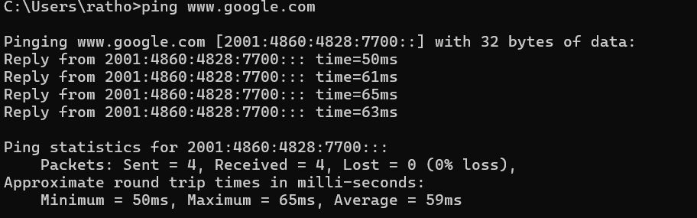
N+ Network Security
Network Troubleshooting, Management, Monitoring & Optimization
1. Use the Windows command prompt to run the command ipconfig /all on your computer and take a screenshot of the output. Identify and write down your IPv4 address, subnet mask, default gateway, and DNS servers as shown in the result.
= 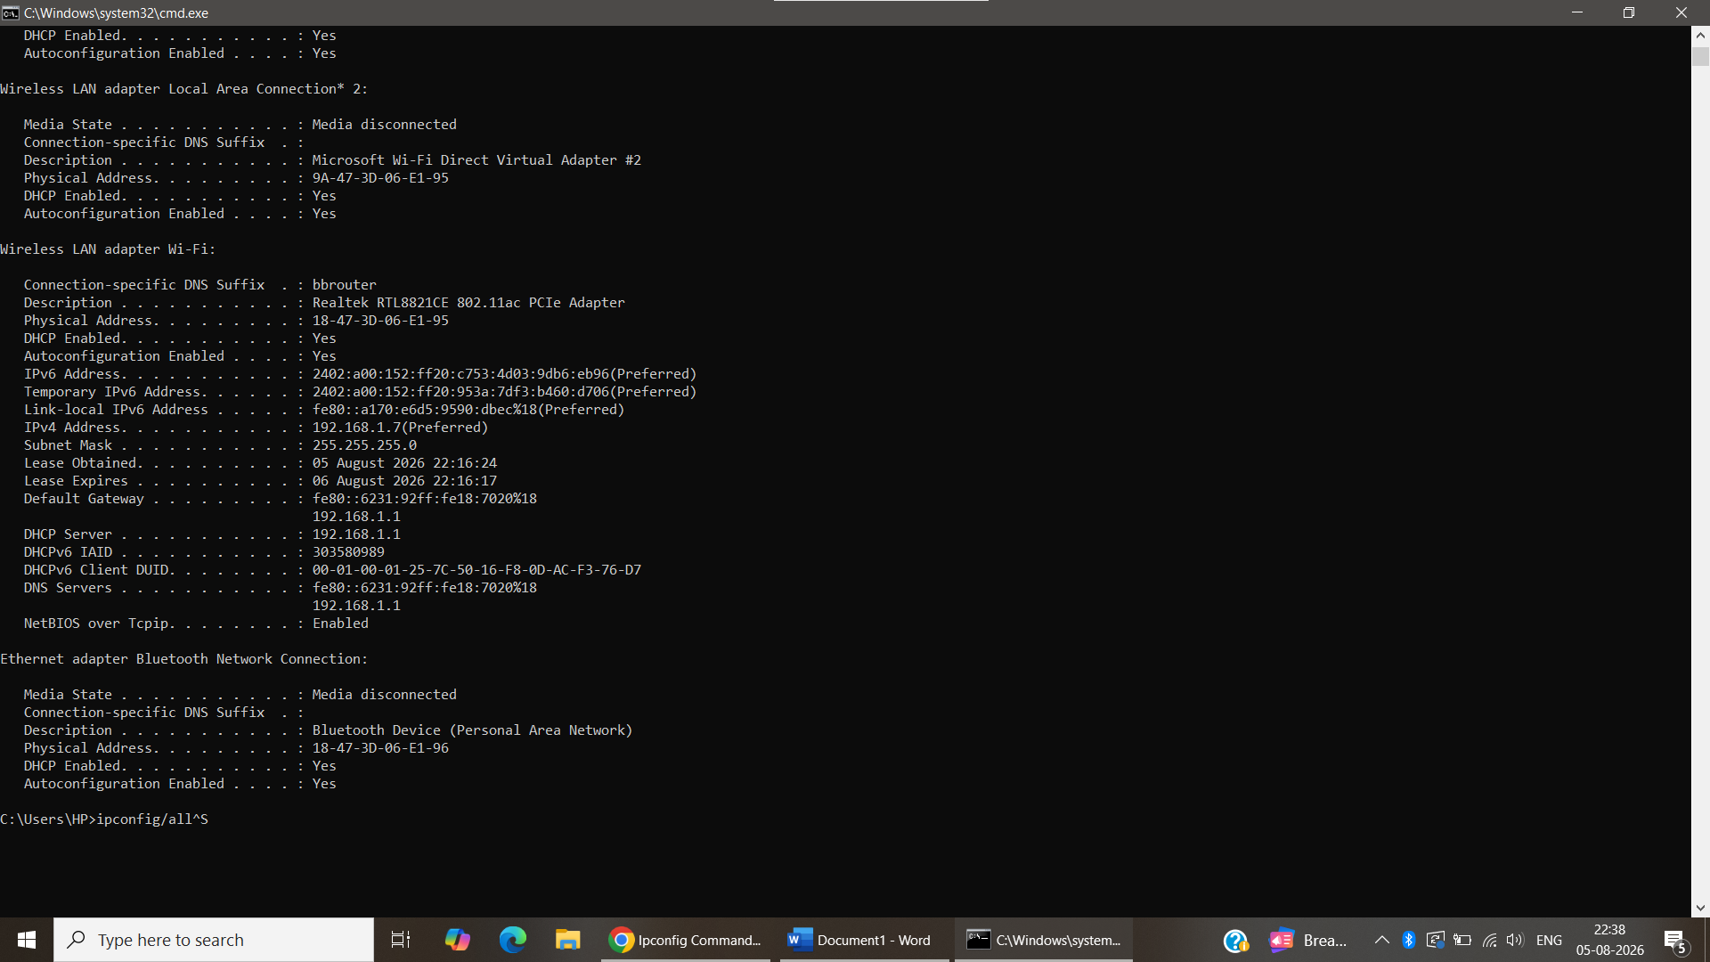
2. Simulate a network connectivity issue by disconnecting your Wi-Fi or Ethernet cable, then use the ping command to check connectivity to www.google.com. Reconnect and repeat the ping. Write a short note on the difference in results and what each status means.
= 
3. Open Task Manager or Resource Monitor on your system and monitor network usage for 5 minutes while streaming a YouTube video. Record the peak network usage value and note which process used the most bandwidth during this time.
= 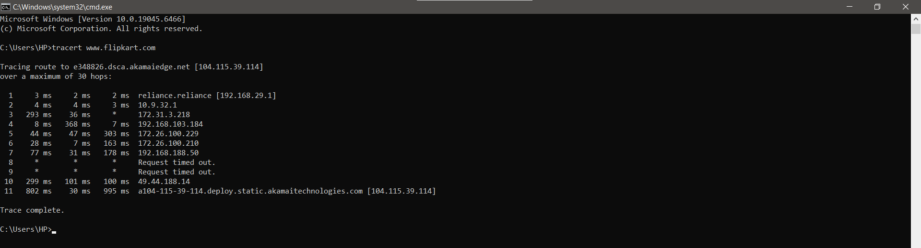
4. Download and install Wireshark (or use an online packet capture demo if installation is not possible). Capture at least 30 seconds of network traffic while browsing Flipkart or Instagram Web, then filter the packets to show only HTTP or HTTPS traffic. List 3 types of information you can see in these filtered packets.<br><br><em><strong>Hint:</strong> Use the filter bar in Wireshark and try http or https as the filter keyword.</em>
= 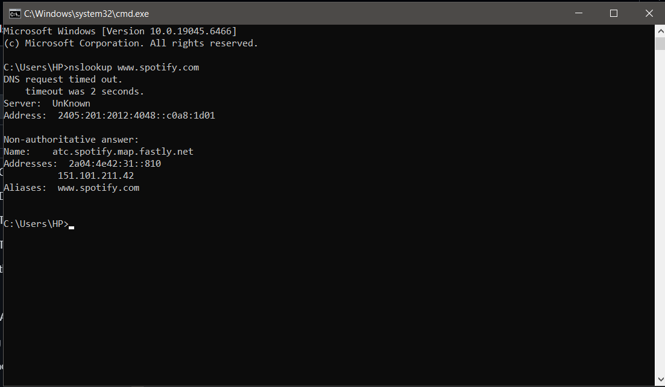
5. Imagine your friend is complaining about slow internet while gaming online. Use ChatGPT or any AI tool to generate a troubleshooting checklist (at least 5 points) for optimizing home network speed and reliability. Paste the AI's response and highlight one suggestion you would try first.
=
No. | Troubleshooting Checklist | Purpose
1 | Restart the modem and Wi-Fi router. | Refreshes the internet connection and fixes temporary issues.
2 | Use a wired Ethernet connection. | Reduces lag and provides a more stable connection.
3 | Stop downloads, streaming, or other heavy internet usage. | Frees up bandwidth for gaming.
4 | Place the router in a central, open location. | Improves Wi-Fi signal strength and coverage.
5 | Update the router's firmware and network drivers. | Improves performance, stability, and security.
6 | Run a speed test and ping test. | Checks internet speed and network latency.
7 | Contact your ISP if the problem continues. | Helps resolve issues related to the internet service.

